# Brainstorm

**& idea prioritization**

## Use this template in your own

**the problem is about to spare of time in purchasing cloths which is need to be multiple pages used by a single user and often spammed with notification**

**problem**

confirm order notification

24 x 7

support

### 1

**Define your problem statement**

What problem are you trying to solve? Frame your problem as a How Might We statement. This will be the focus of your brainstorm.

**5 minutes**

### 2

**Brainstorm**

Write down any ideas that come to mind that address your problem statement.

**10 minutes**

#### Vigneshwaran ArulSelvan Madhan

find exact product

multiple languages

History of order

Reduce Stress for Consumers

time saving

manage user choice

personalized experience

**3**

### Group ideas

Take turns sharing your ideas while clustering similar or related notes as you go. In the last 10 minutes, give each cluster a sentence-like label. If a cluster is bigger than six sticky notes, try and see if you and break it up into smaller sub-groups.

**20 minutes**

**4**

### Prioritize

Your team should all be on the same page about what's important moving forward. Place your ideas on this grid to determine which ideas are important and which are feasible.

**20 minutes**

## brainstorming sessions so your team can unleash their imagination and start shaping concepts even if you're not sitting in the same room.

Chat bot

User Requirements

**10 minutes** to prepare

collect feedback

find exact product

instant responses

without expenses of human representative

allow business to connect with customer

**1 hour** to collaborate

**2-8 people** recommended

#### Sakthivel

rated fashion products

24x7 support

customer service

rated fashion products

**without expenses of human representative**

gather customer insights

time saving

personalized experience

instant response

**Key rules of brainstorming**

To run an smooth and productive session

user requirements

personalized experience

basic need

### Importance

If each of these tasks could get done without any difficulty or cost, which would have the most positive

allow business to connect with customer

manage user choice

Stay in topic. Defer judgment.

share review and ratings

collect feedback

offers different option

gather customer insights

Encourage wild ideas. Listen to others.

impact?

Go for volume. If possible, be visual.

gather customer insights

multiple languages

customer service

History of order

rated fashion products

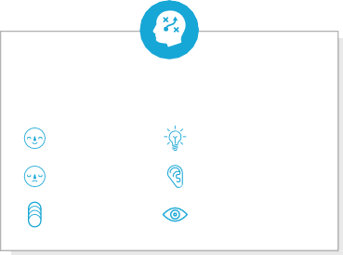

**Template**

[**Share template feedback**](https://muralco.typeform.com/to/CiqaHVat?typeform-source=app.mural.co)

### Feasibility

Regardless of their importance, which tasks are more feasible than others? (Cost, time, effort, complexity, etc.)